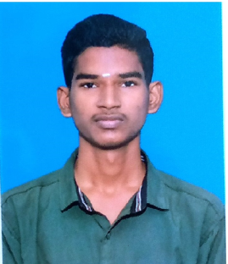**K.SANTHOSH**

Email ID:**<sandy07072004@gmail.com>**

Contact No : **+91-9344724761**

|  |
| --- |
| Career Objective |

Deserving candidate for any working condition seeking job for exposing full dedication and skills for better outcome.

|  |
| --- |
| **TECHNICAL SKILL** |

**INFORMATION TECHNOLOGY:**

* + Handling all computers
  + Programmer
  + Code Editor
  + Game Tester

**Area of the Interest**

Programmer

|  |
| --- |
| Profile Summary |

Eager to learn new technologies and methodologies.

Willing to innovate and develop engineering that can improve existing technology.

|  |
| --- |
| Personality Traits |

* Highly self-motivated.
* Ability to produce best result in pressurized situation.
* Good communication skills in written and verbal both.
* Ability to work as individual and in group too.

|  |
| --- |
| Academic |

Bachelor of Science INFORMATION TECHNOLOGY in **ARUMUGAM PILLAI SEETHAI AMMAL COLLEG** with (2021-2024)

SSLC from **SATHAPPA GOVT HR SEC SCHOOL**with 79.25%.

|  |
| --- |
| Technical Qualification |

* + JAVA
  + C++
  + MS Office.

**EXPERIENCE.**

**NOTHING**

|  |
| --- |
| Extra Curricular Activities |

* Reading Books.
* Exploring towards unseen.
* Chess
* Cricket

|  |
| --- |
| Personal Details |

Languages Known- English, Tamil, Hindi.

DOB- 07-07-2004

Address- 51A,Sathappa school backside,Nerkuppai.Sivagangai (dt)

|  |
| --- |
| DECLARATION |

Details provided above are true to the best of my knowledge and will be made for the new innovations.



**PLACE:**

**DATE :**

Signature